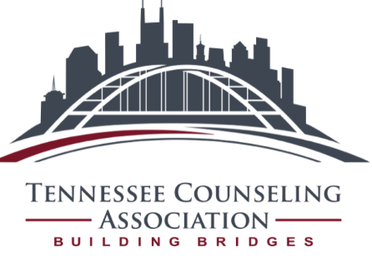
Call for Presentation Proposals
The Tennessee Counseling Association announces its open call for presentation proposals for the 62nd annual Tennessee Counseling Association Conference, November 7-10, 2019, at the Marriott Nashville Airport Hotel in beautiful Nashville, Tennessee. Join us as we explore our theme: Counselors Building Bridges. A number of national speakers including Dr. Sam Gladding, Dr. Brande Flamez, Dr. Gerald Pennie, and others will be featured and offer keynote addresses and learning sessions. Don’t miss out!

Conference Details:
During the span of our conference we will have several speaking opportunities:
- Friday (11/8): Learning Institutes (included with registration), breakout sessions that are 3-hours in length
- Friday (11/8), Saturday (11/9), Sunday (11/10): Breakout sessions that are 75 minutes in length
As an additional conference benefit, conference attendees can attend a pre-conference session on Thursday (11/7) for an additional $25. A session will be offered on “Using Technology in Counseling: Ethical Issues and Responsibilities”. This will qualify for an additional 4 CEs (2 in ethics).

Proposal Submissions:
To submit a proposal, complete the following Proposal Outline (below) and submit to tca19proposals@tcacounselors.org no later than April 1, 2019. The TCA proposal committee will review each submission and send disposition emails by May 15, 2019.
As a presenter*, you will receive a $15 discount on the cost of conference registration. Note that all presenters must register for the conference by August 31st, 2019. Registration will be opening in early 2019 – watch our website at http://www.tcacounselors.org/conference
*Students and retired members already receive discounted rates based on their status and are, therefore, not eligible for an additional presenter discount. The presenter discount is also not available on Day-Passes.
Proposal Outline:

Name(s) of presenter(s) and credentials:
Time (Please select one): 3 hour or 75 minutes
Program Description (To be printed in the program booklet. Must be 75 words or less):
Program Synopsis (What is the major focus of your presentation? 50 words or less):
Goal of Presentation (What do you hope to accomplish? 25 words or less):
Objectives (Submit 3 objectives that describe what participants will learn from your program):
Content (What does the literature or research say about this topic? How is it relevant to counseling? 50 words or less):
Format (What will the presentation look like? Walk us through the steps. Is it experiential? Discussion? Case Based? 50 words or less):
Submit to: tca19proposals@tcacounselors.org
Due: April 1, 2019
Disposition emails by: May 15, 2019

Thank you for your interest in presenting.
We look forward to seeing you at Conference in November!

